# IoT-BASED EV SMART PARKING AND GREEN CHARGING SYSTEM

### A PROJECT REPORT

***Submitted by***

**KUSHAL SINGH [Reg No: RA1911003030129] ANMOL MADDHESHIYA [Reg No: RA1911003030140]**

**SIDDHARTH SINGH [Reg No: RA1911003030148] SATYAM KUMAR [Reg No: RA1911003030158]**

*Under the guidance of*

## Nishant Anand

(Asst. Professor, Department of Computer Sciene & Engineering)

***in partial fulfillment for the award of the degree of***

### BACHELOR OF TECHNOLOGY

in

## COMPUTER SCIENCE & ENGINEERING

of

### FACULTY OF ENGINEERING AND TECHNOLOGY



#### S.R.M. NCR Campus, Modinagar, Ghaziabad

**SRM INSTITUTE OF SCIENCE & TECHNOLOGY**

(Under Section 3 of UGC Act, 1956)

## BONAFIDE CERTIFICATE

Certified that this project report is titled “**IoT-BASED EV SMART PARKING AND GREEN CHARGING SYSTEM”** is the bonafide work of **KUSHAL SINGH[Reg No:RA1911003030129] ,ANMOL MADDHESHIYA [Reg No:RA1911003030140] ,SIDDHARTH SINGH [RegNo:RA1911003030148],**

#### **SATYAM KUMAR [Reg No:RA1911003030158]** who carried out the project work under my supervision. Certified further, that to the best of my knowledge the work reported herein does not form any other project report or dissertation on the basis of which a degree or award was conferred on an earlier occasion on this or any other candidate.

**SIGNATURE**

Nishant Anand

**GUIDE**

Asst. Professor

Dept. of Computer Science & Engineering

Signature of the Internal Examiner

**SIGNATURE**

Dr. R.P.Mahapatra

**HEAD OF THE DEPARTMENT**

Dept. of Computer Science & Engineering

Signature of the External Examiner

# ABSTRACT

#### The development and growth of electric vehicles(EVs) have increased several folds during the last 10 years. EVs are a green and sustainable alternative to LPG and diesel vehicles that pollute and threaten the environment, especially for CO2 reduction and alternative energy uses. Due to the increasing popularity of EVs nowadays there is an increased demand for charging stations. Additionally, parking cars has always been a difficult chore. Consequently, EV also needs a reliable parking system. Our current project entails "Smart Parking as well as Green Charging system of EV”. We are using the Node MCU, Arduino UNO, Servomotor, and 6 IR sensors to develop an IOT-based car parking system. For a hassle-free parking system, we leverage the Internet of Things (IoT) and getting the information on Blynk application about the slot availability. The 2nd part of the project deals with the challenge of charging the EVs using a 15Vsolar panel that would be used to charge a 12V battery which rests on the platform where the designated car is parked.

**ACKNOWLEDGEMENTS**

I would like to express my deepest gratitude to my guide, Nishant Anand Assistant Professor his valuable guidance, consistent encouragement, personal caring, timely help and providing me with an excellent atmosphere for doing research. All through the work, in spite of his busy schedule, he has extended cheerful and cordial support to me for completing this research work.

**-Kushal Singh**

**-Anmol Maddheshiya**

**-Siddharth Singh**

**-Satyam Kumar**

**TABLES OF CONTENT**

**ABSTRACT**…………………………………………………………………………3

**ACKNOWLWDGEMNT**………………………………………………….4

**Chapter – 1** ……………………………………………………..6

**INTRODUCTION**……………………………………………………....6

* 1. Internet of things(IoT) Introduction………………………..6
  2. Electric Vehicle…………………………………………....7

**Chapter – 2**………………………………………………………………8

**LITERATURE SURVEY**…………………………………………………......8-10

**Chapter – 3** …………………………………………………………………………11

**EXISTING PROBLEM AND PROPOSED SOLUTION**……………………....11

3.1 Objective……………………………………………………………....11

3.2 Existing Problem …………………………………………………….11-12

3.3 Proposed Solution……………………………………………………12-13

3.4 Flow Chart…………………………………………………………..14

**References**…………………………………………………………………………...15

# CHAPTER 1

## INTRODUCTION

Now-a-days Electrical vehicle is a trending topic and it is an important part of this smart world. Drawback of electric vehicles is cruising range is typically limited. So, it requires frequent recharging. Not only for electric vehicle but population is increasing exponentially and the problem due to this is, increasing traffic volume. All we know that we have limited stock of the fuel on our earth so it is need of time that we must switch to another way and electricity is the best option for it and electric vehicle is example of it. Electrical vehicle require a charging station similar to current fuel car require a petrol pump and obviously charging takes some time .So it is better to charge the car when it is parked, therefore it is efficient to combine both the charging and parking system which is based on the IoT technology which makes the system user friendly. We are using solar panel for green charging, making the system an efficient as well as a renewable.

# Internet of Things (IoT) :-

The Internet of Things (IOT), is the network of physical objects or “things” embedded with electronics, software, sensors, and network connectivity, which enables these objects to collect and exchange data. The Internet of Things allows objects to be sensed and controlled remotely across existing network infrastructure, creating opportunities for more direct integration between the physical world and computer-based systems, and resulting in improved efficiency, accuracy and economic benefit. Each thing is uniquely identifiable through its embedded computing system but is able to interoperate within the existing Internet infrastructure. Overall the number of IoT devices across all industry verticals is forecast to grow to more than eight billion by 2030.

# Electric Vehicle :-

Electric vehicles (EVs), also referred to as battery electric vehicles, use a battery pack to store the electrical energy that powers the motor. EV batteries are charged by plugging the vehicle in to an electric power source. Although electricity production may contribute to air pollution, the

U.S. Environmental Protection Agency categorizes all-electric vehicles as zero-emission vehicles because they produce no direct exhaust or tailpipe emissions. Both heavy-duty and light- duty EVs are commercially available. EVs are typically more expensive than similar conventional and hybrid vehicles, although some cost can be recovered through fuel savings.

# CHAPTER 2

## LITERATURE SURVEY

To understand the establishment of proposed work it is necessary to examine the existing literature and to determine how the parameters are monitored. In addition, it is important to validate how efficiency of other integrated algorithms is improved.

##### A Review on IoT based Electric Vehicle Charging and Parking System, International Journal of Engineering Research & Technology (IJERT) Vol. 9 Issue 08 (S. Phadtare , S.S. Wadkar , S.S. Thorat , A.S. Ghorpade, Mr.A.B. Jadav) - 2020

Electrical vehicles require a charging station similar to current fuel car require a petrol pump and obviously charging takes some time so it is better to charge the car when it is parked, therefore it is efficient to combine both the charging and parking system which is based on the IoT technology which makes the system user friendly . One can upload information on cloud and simultaneously on smart phones. Car safety while parking is one of the issues faced by people. The internet of things (IoT) is best platform for monitoring the status of WPT system which is able to provide the wider connectivity, modified sensing, information processing and greater flexibility. talks about “Wireless charging system” and “Inductive Power Transfer”. Under wireless charging system, this paper covers various aspects of wireless charging of electric vehicles, fundamental operation of wireless charging system including inductive wireless charging technique. It compares the inductive power transfer for different charging systems. Overall, this paper compares various smart parking, charging and combined charging-parking system, which can help to solve various issues related with it. Also, it contains a table of comparison of various research papers. Various types of methods and techniques used for parking and charging are discussed. Various sensors, controllers, software and cloud servers are available at market which will help to make system automatic, reliable and user friendly along with development of efficient IoT platform .

##### IoT based Smart Car Parking with Wireless Charging Feature for Electric Car, International Research Journal of Engineering and Technology (IRJET) Volume:07 Issue:08 (Ms. Lekshmi M, Mr. Mayur P, Mr. Manjunatha B , Ms. Kavya U, Mr. Anil Kumar J H)

The problem of finding a parking space in metro cities is a herculean task in the fast moving world. The need of the hour is an IoT backed solution wherein the availability is based on the reservation management facility. This paper talks of employing an app based IoT smart parking system. In order to prevent long waits at the EV charging station, the parking system is equipped with wireless charging scheme for electric vehicles. This serves dual advantage of parking vehicles as well as charging of electric vehicles. The Wireless charger designed is a Resonant Inductive Power Transfer System employed due to its consumer suitability and its effect on battery performance. The coil coupling and power electronics infrastructure decide the efficiency of the charging system and hence facilitates the charging of Electric Vehicles at the same speed as that of standard AC plug-in chargers.

##### IoT Based Electric Vehicle Application Using Boosting Algorithm for Smart Cities (Shabana Urooj, Fadwa Alrowais, Yuvaraja Teekaraman, Hariprasath Manoharan, Ramya Kuppusamy) 2021

To overcome all issues in existing vehicles and for protecting the environment, electric vehicles should be introduced by integrating an intellectual device called sensor all over the body of electric vehicle with less cost . Therefore, this paper confers the need and importance of introducing electric vehicles with IoT based technology which monitors the battery life of electric vehicles. An online monitoring system which is called Things Speak has been used for monitoring all the vehicles in a continuous manner (day-by-day). These online results will then be visualized in MATLAB after an effective boosting algorithm is integrated with objective function . It was observed that cost of implementation is lesser and capacity of electric vehicle

is increased to about 74.3% after continuous monitoring with sensors.

##### IoT Enabled Smart Charging Stations for Electrical Vehicles,Journal of Telecommunication Study Volume: 4 Issue: 2 (Esha Sharma, Bharath S, Adarsh Devaramani, Deepti Sr, Saravana Kumar) 2021

This paper makes a smart application to know the different tariff rates of the grid by connecting to the grid. The tariff rates include both, the power intake rate and also the outgoing power rate. When the user comes to the grid, the application also displays the battery SOC. The main agenda of this paper is to optimize low carbon technologies through one connected platform using rule based algorithms, helping to decarbonize both the production and consumption of energy. The status of the battery is computed by the Arduino uno (microcontroller), then the computed data is stored in cloud, where the ESP8266 acts as intermediate device between the microcontroller and the network. The stored data is accessed by the cloud using certain applications like Adafruit, MQTT dash board etc. Hence the user will get to know about their car’s battery status and also they can provide excess amount of charge to any other applications, by knowing the status of the battery.

* 1. **An article on “PARKPLUS Electric Vehicle Charging for Automated Parking” 2021**

PARKPLUS Electric Vehicle Charging is an integrated solution to provide project-specific EV charging capacity to PAR;KPLUS Automated and Semi-Automated Parking Systems. The PPEVC solution is designed for pallet-based parking systems and parking platforms that include power for manual connection when parking. In this, charging power is connected upon manual connection, or when the parking platform arrives at designated parking.

# CHAPTER 3

**Existing Problem and Proposed Solution**

## Objective

* + - To provide information about slot availability for parking using Blynk application
    - To provide wired-charging of Electric Vehicle
    - To provide green charging using solar panels.

## Existing System

* + - Urban living needs centralized public facilities.
    - Almost no car parking facilities in operation today can handle the flood of vehicles.
    - It takes time to look for a vacant parking space.
    - It causes increased traffic congestion since many vehicles may compete for limited parking spaces.
    - After that there is also a problem with EV charging points across the city.
    - EV charging points are yet to upgrade to a renewable source of energy.

Car parking is a major problem in urban areas in both developed and developing countries. Following the rapid incense of car ownership, many cities are suffering from lacking of car parking areas with imbalance between parking supply and demand which can be considered the initial reason for metropolis parking problems. This imbalance is partially due to ineffective land use planning and miscalculations of space requirements during first stages of planning. Shortage of parking space, high parking tariffs, and traffic congestion due to visitors in search for a parking place are only a few examples of everyday parking problems.

The paper examines car parking problem in the city; its different causes and conventional - yet non-successful - approaches. Modern technology has produced a variety of new solutions and techniques in this respect. The paper reviews new planning trends and creative technological solutions which can help alleviate the strain of the problem. Because car parking solutions are not an end in itself, but rather a means of achieving larger community goals in order to improve urban transportation and make cities more livable and efficient, the paper also discusses the environmental impacts which should be taken into considerations for solutions proposed.

## Proposed System

* + - To provide information about slot availability for parking using IoT App/Browser.
    - To provide wired charging of Electric Vehicle .
    - To provide green charging using solar panels.
    - EV Smart Parking System

## General Smart Parking Architecture

Finding for a car parks space becomes an everyday problem for most of the public entirely to the world. It commonly takes more periods overwhelming method for most of the people in everyday life. Smart parking provides parking solution which includes smart car parks devices, cameras or calculating devices. These expedients are commonly fixed in car parks places which is used to identify the whether the car parks spot is open or not. Smart parking and parking sensors are portion of smart metropolises. Smart metropolises are motivated by IT substructure to improve the superiority of lifetime and expand commercial improvement. Smart city can collect historical data in easy way, so that parking can be optimized. The smart parking system saves the driver time for parking a car in vacant place. The amount of time is considering for car parks spot is will be minimalized. The advantages of smart car parks systems are less pollution, safety, real time parking analytics, the space of a metropolis will be used extra proficiency, reduce street congestion, the drivers will get the benefit for

reduce stress related to parking, save time and money. The general smart Parking

architecture consists of three parts. The sensor and cameras are used to detect the car in entrance, Browser and mobile app used for Web service IoT, the database is used to register vehicle information.

## EV Green Charging System

Consumers and fleets considering plug-in electric vehicles (PEVs)—which include plug-in hybrid electric vehicles (PHEVs) and all-electric vehicles (EVs)—need access to charging stations. For most drivers, this starts with charging at home or at fleet facilities. Technologically, adopting the electric vehicle technology is a good initiation to go green. Building solar charging stations could constitute a small step to encourage people to opt for Electric vehicles.

* 1. **FLOW CHART OF SMART PARKING SYSTEM**

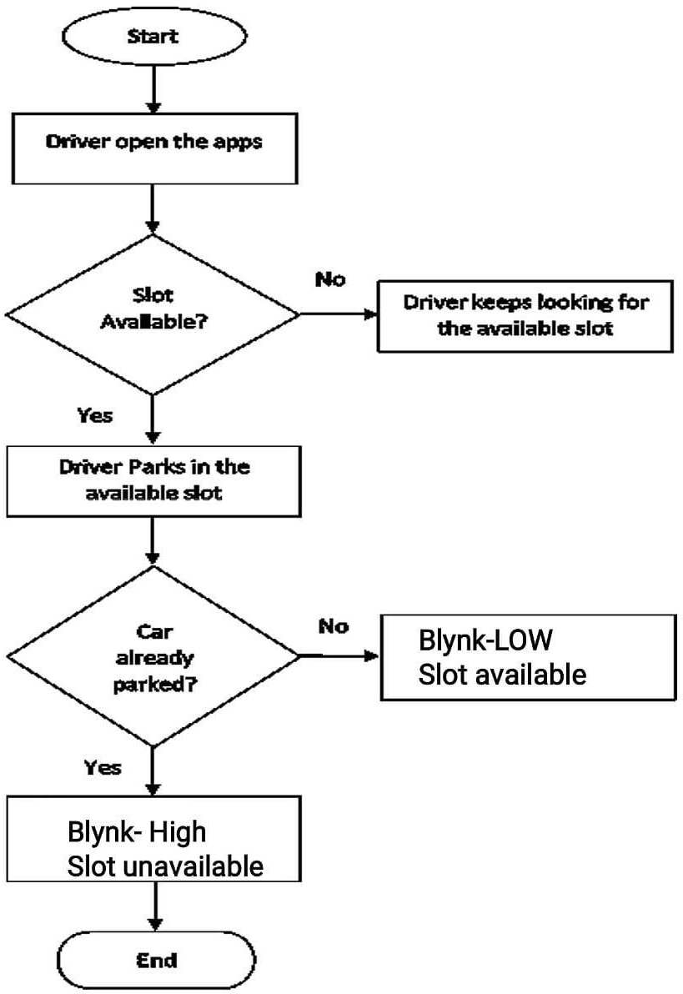

# REFERENCES

* Review on IoT based Electric Vehicle Charging and Parking System, International Journal of Engineering
* Research & Technology (IJERT) Vol. 9 Issue 08 (S. Phadtare , S.S. Wadkar ,

S.S. Thorat , A.S. Ghorpade, Mr.A.B. Jadav)

* IoT based Smart Car Parking with Wireless Charging Feature for Electric Car, International Research Journal of Engineering and Technology (IRJET) Volume:07
* Issue:08 (Ms. Lekshmi M, Mr. Mayur P, Mr. Manjunatha B, Ms. Kavya U, Mr. Anil Kumar J H)
* IoT Based Electric Vehicle Application Using Boosting Algorithm for Smart Cities (Shabana Urooj, Fadwa Alrowais, Yuvaraja Teekaraman, Hariprasath Manoharan, Ramya Kuppusamy)
* IoT Enabled Smart Charging Stations for Electric Vehicles, Journal of Telecommunication Study Volume:4 Issue:2 (Esha
* Sharma, Bharath S, Adarsh Devaramani, Deepti Sr, Saravana Kumar)
* An article on “PARKPLUS Electric Vehicle Charging for Automated Parking”